**Coding assignments for CareLinx candidates**

**Below are 3 assignments. Code them up in whatever tool you prefer. Where relevant, a demo would be great.**

**What we look for:**

* Code that works
* Elegance of solution
* Good code style, error handling, and comments
* Any extras to impress us

**====**

**Assignment 1**

Write a JavaScript function (or Python) to convert an amount to the least number of coins.

Sample function : amountToCoins(46, [25, 10, 5, 2, 1])

Here 46 is the amount. and 25, 10, 5, 2, 1 are a set of denominations of the coins.

Output : 25, 10, 10, 1

The function can take any integer amount and any number of coin denominations in any order.

Add logic to return false for amount <= 0 and for edge cases where combination is not possible.

**Aassignment 2**

Extract the text from two objects (node 1 and node 2). Once you’ve extracted the text from both objects check if they are the same.  
Every object will contain three properties (**is_text**, **string**, **children**). **children** will contain a list of objects with the same properties. **is_text** will contain a boolean value that will help you determine if that object contains text or not. **string** contains the text of the node.

**Object structure (Node)**:

is_text

string

Children  
  
**Example:**

node1 = {"is_text": false, "string": None, "children": [{"is_text": false, "children": [{}]}, ...]}

node2 = {"is_text": false, "string": null, "children": [{"is_text": false, "children": [{}]}, ...]}

**Visualisation:**

Imagine that you have two HTML documents. Within each document you have a basic HTML Structure. Your task will be like going through each DOM node to verify if it contains a piece of text. If it does, save it and add it to the other pieces that you’ve collected so far. Once you’ve gone through all of the document verify if the text that you’ve collected for both documents is the same.

Doc1:

<html>

<body>

Hello

</body>

</html>

Doc2:

<html>

<body>

<b>H</b>

<ul>

<li>e</li>

<li>llo</li>

</ul>

</body>

</html>

**Example:**

**Doc1:**

<html>

<body>

Hello

</body>

</html>

**Node1:**  
{  
 #This is the <html>

"is_text": False,

"string": None,

"children": [

{

#This is the <body>

"is_text": False,

"string": None,

"children": [

{

"is_text": True,

"string": "Hello"

}

]

}

]

}

**Assignment 3: HTML, CSS, Javascript**

Create the following layout using HTML and CSS. You should use Bootstrap’s (http://getbootstrap.com/) grid system to complete this challenge.

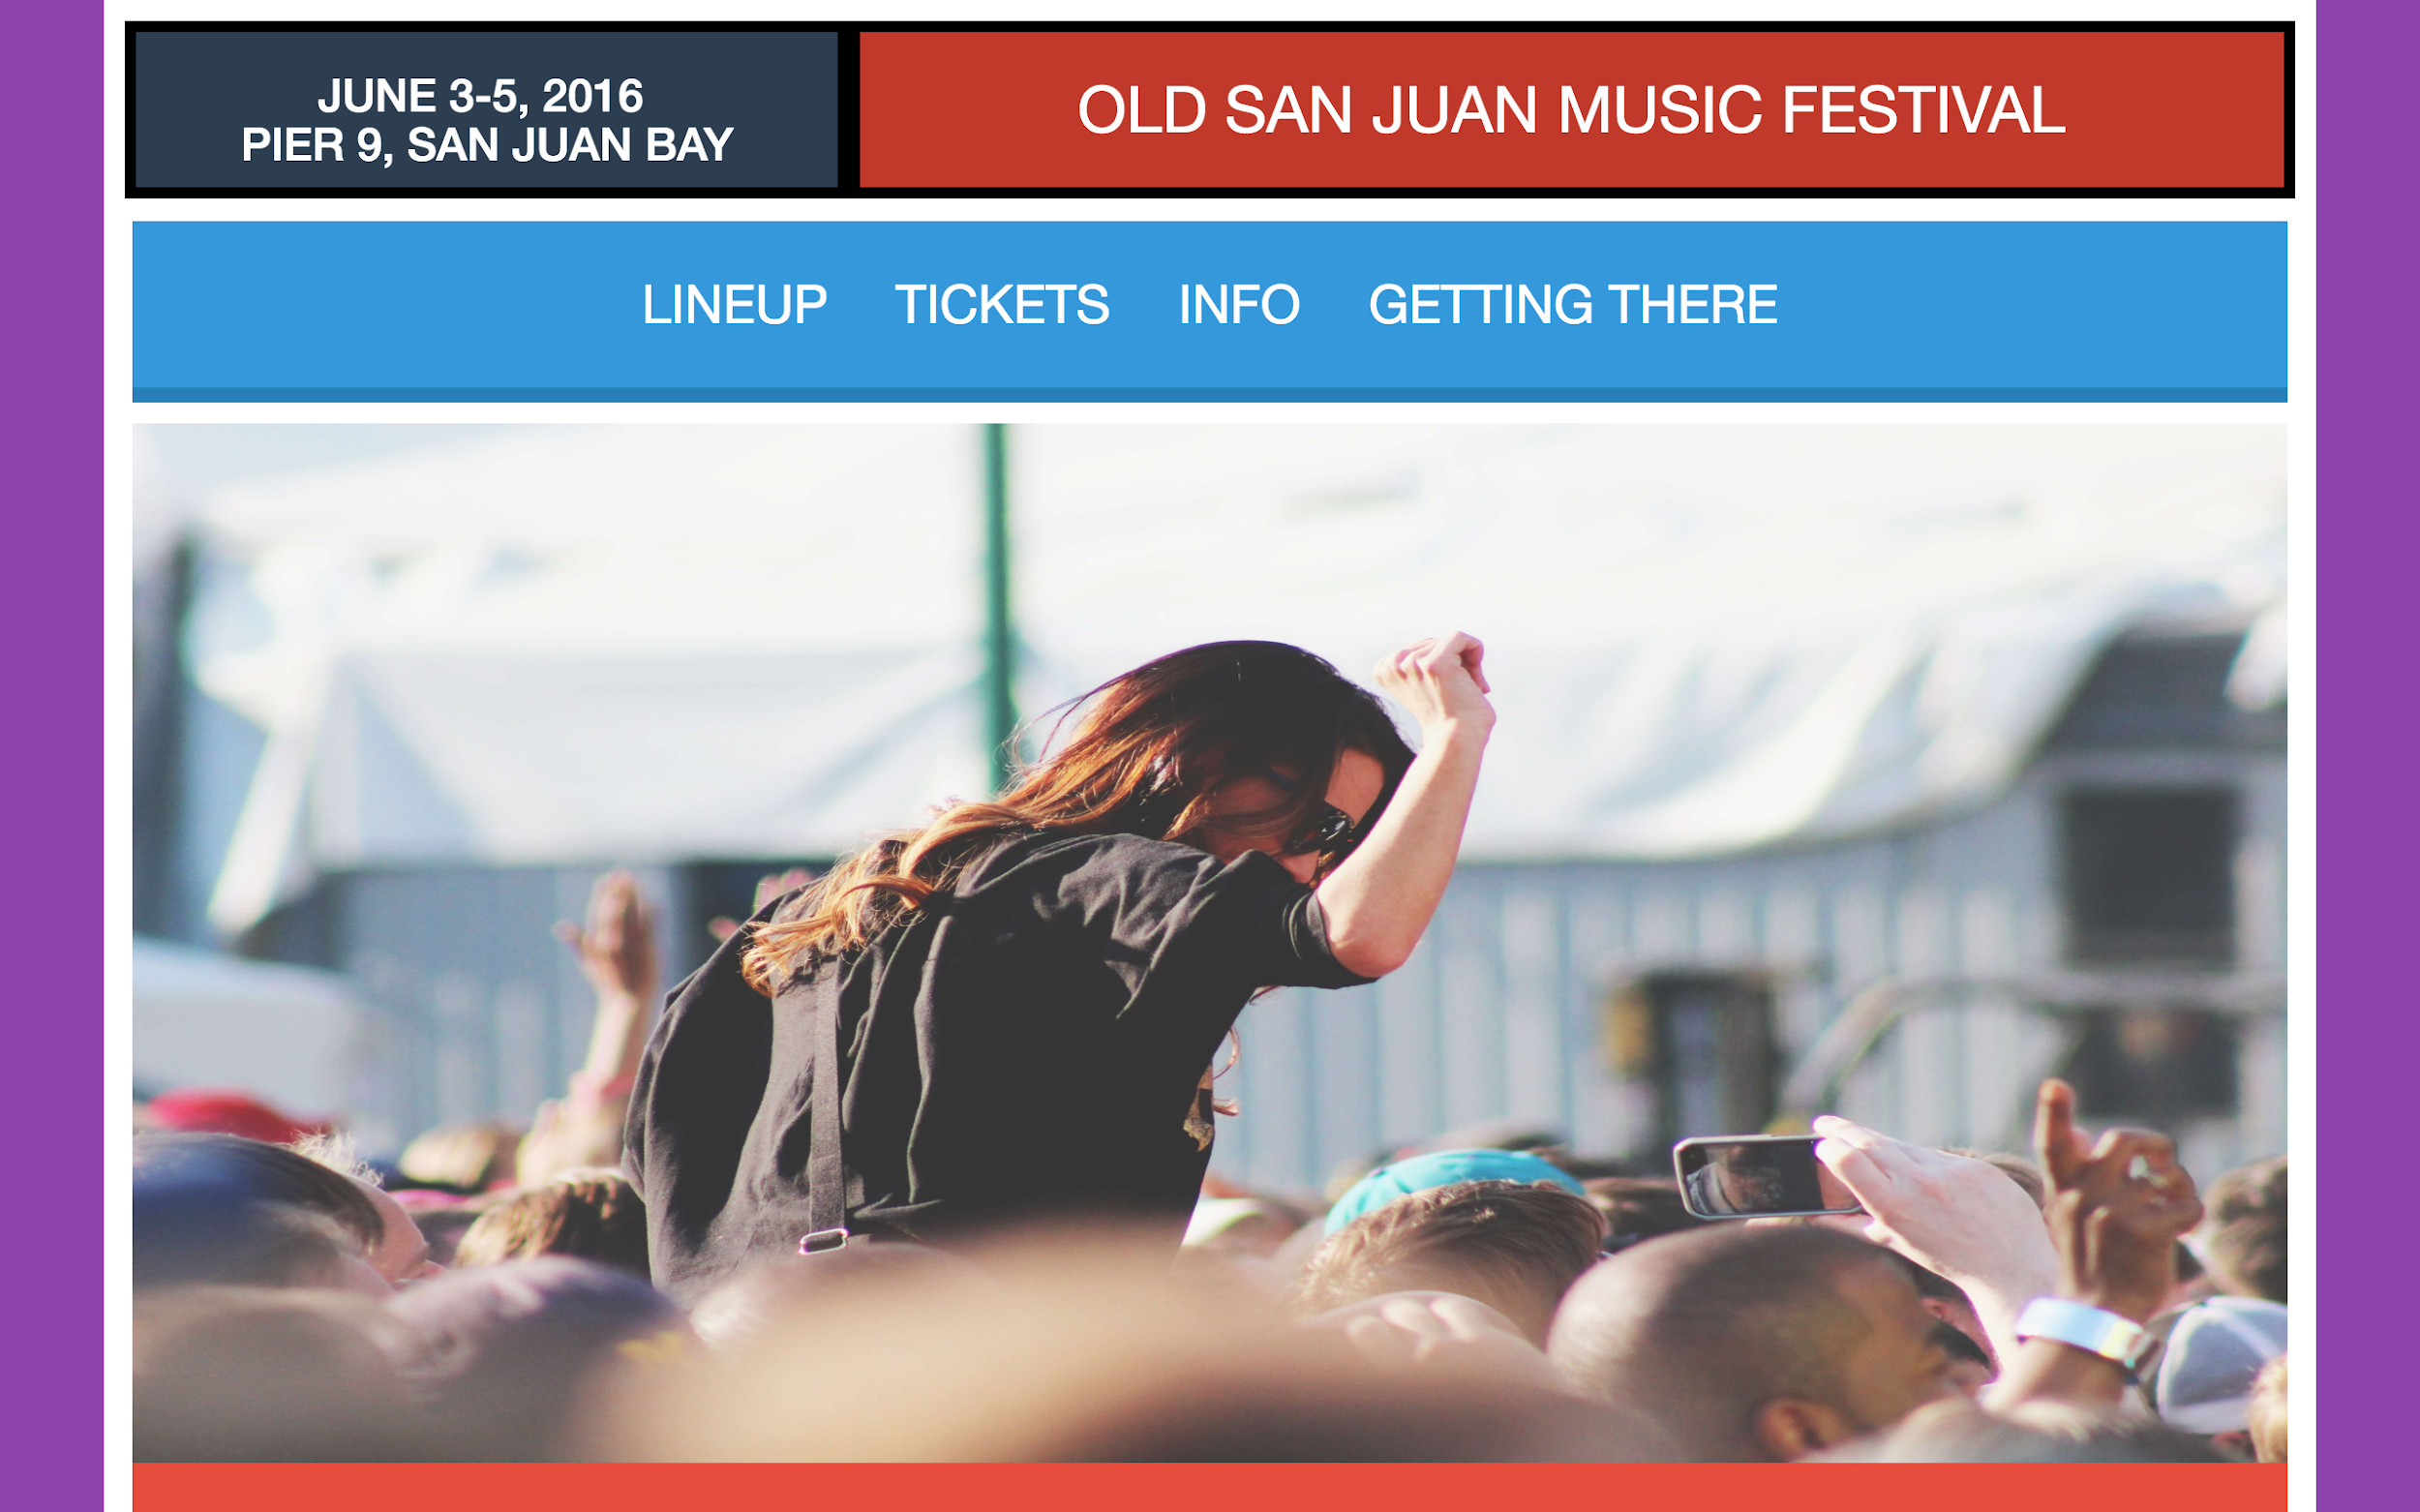

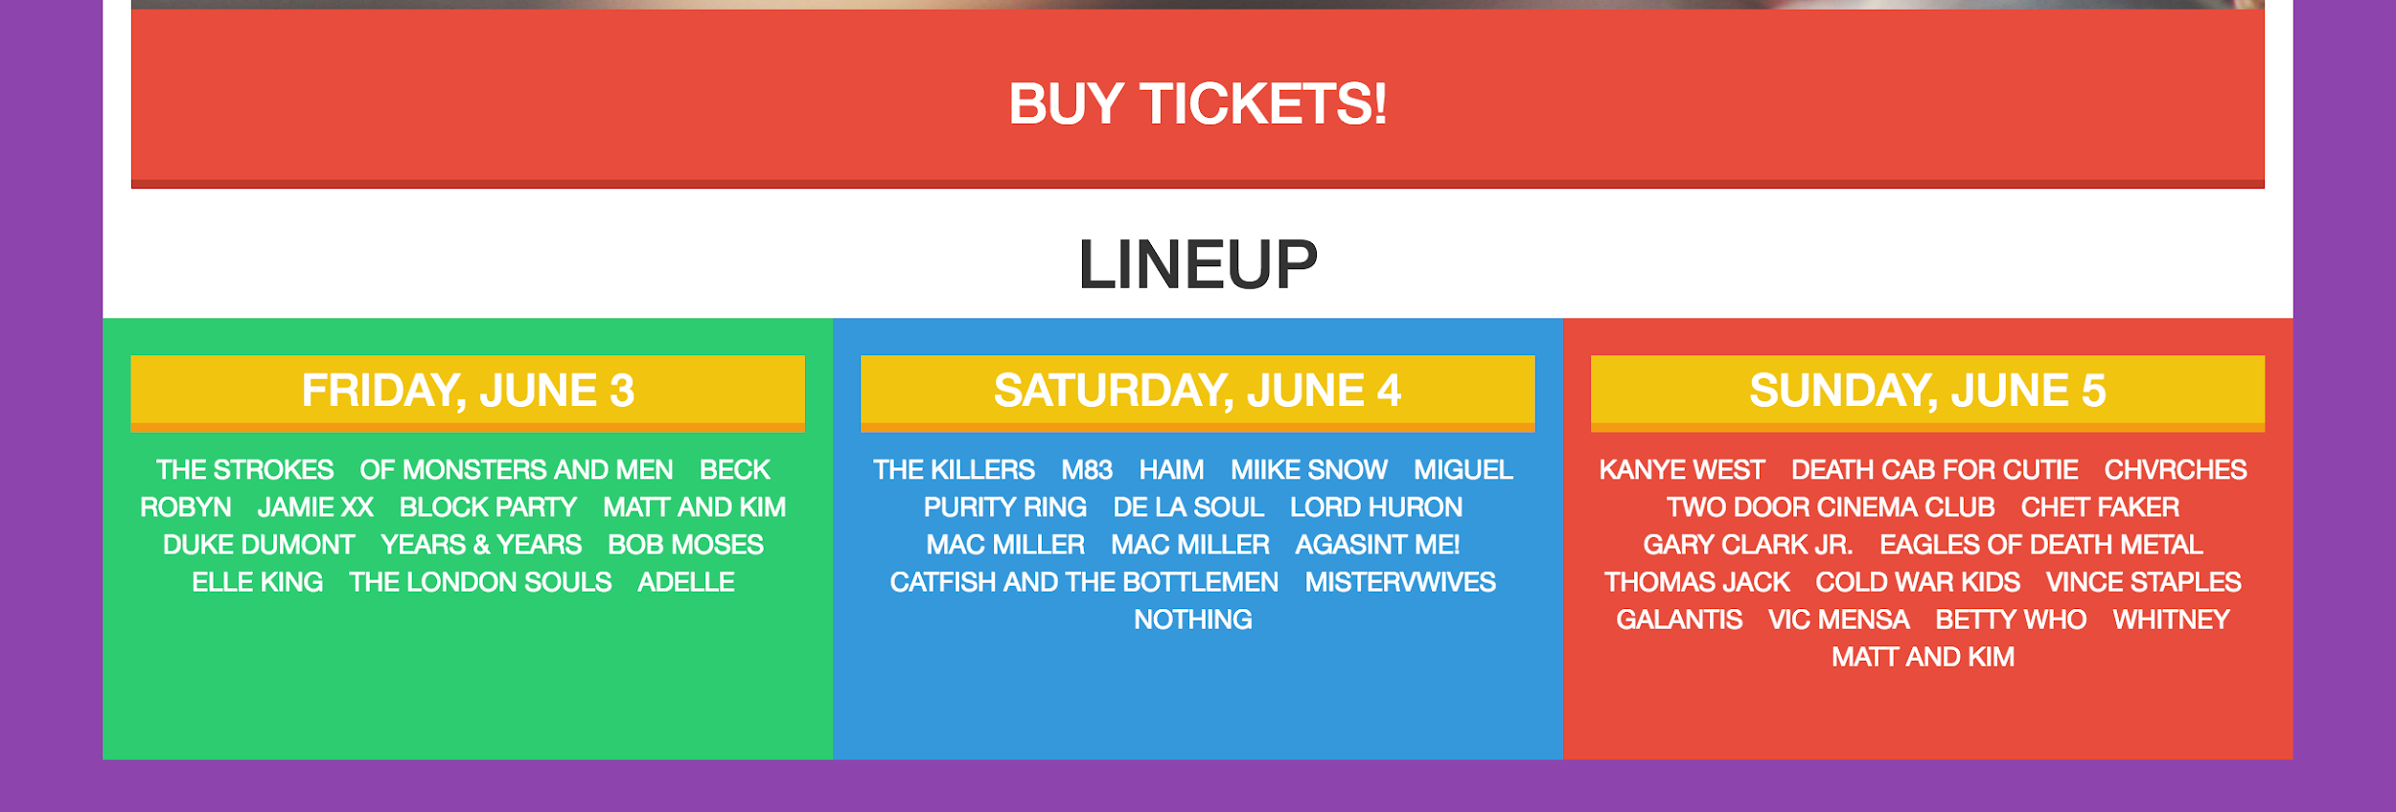

To complete this section you will need to add three containers that will hold the pictures for the lineup dates. By default these containers will be hidden. In order for you to display them you will need to add jQuery (<https://jquery.com/>) event listeners. Your task is to add an event listener that will display the pictures for a specific day when it’s clicked once. If the box is clicked two times you should hide the pictures of the box that was clicked.

If you can’t see the animated gif below, click on this link:  
<https://s3-us-west-2.amazonaws.com/carelinx.public-assets.us-west-2/engineering/images/assignment_3.gif>

